Owner’s Guide
for:
Tanzer 14, Tanzer 16
& Tanzer Overnighter

Table of Contents
INTRODUCTION 2
OWNER 'S GUIDE 3
TO RIG YOUR BOAT: 3
HOISTING THE SAILS 6
REEFING INSTRUCTIONS 7
SNAPTITE CORKS 7
FLOTATION TANKS 8
RUDDER AND TILLER 8
COCKPIT COVER 8
MAINTENANCE 8
STORAGE 9
OUTBOARD MOTOR BRACKET 9
WHISKER POLE 9
SPINNAKER GEAR 10
Tanzer 16 and Tanzer 14 Spinnaker Kit Installation: 10
Tanzer Overnighter Spinnaker Kit Installation: 11
HIKING STRAPS 12
OPTIONAL MAINSHEET TRAVELLER 13
GELCOAT REPAIRS 14
STANDING AND RUNNING RIGGING 15
FITTINGS 15
CARE OF SAILS 15
ADJUSTABLE CLEW OUTHAUL 16

INTRODUCTION

The intention of this Guide is to provide new owners with certain specific information relating to the Tanzer Overnighter, the Tanzer 16 and the Tanzer 14, as well as some general comments about sailboat maintenance, etc. A very large number of publications are available dealing with the many facets of sailing; seamanship, sail trimming, boat maintenance, tuning, racing tactics, racing rules, to name a few. Owners, particularly new sailors, are urged to extend their knowledge and enjoyment of sailing by referring to this extensive range of literature.
Considerable effort has been made to ensure that every Tanzer sailboat will provide many years of sailing pleasure. If you encounter any problems with your boat, please contact either your local dealer or the factory direct. If you write to the factory direct, please do not fail to provide the official number of your boat. This is marked on the plate fastened to the centreboard cap and incorporates the sail number, which is also on the mainsail.

Note: This is a copy of the original guide. This document was transcribed from the original by Gary T. Eaton (1998) and posted on the Tanzer 16 web site, until 2010, by Chris Locke. This version is based on the web document, and was prepared in 2011.

OWNER 'S GUIDE
For:
Tanzer 14, Tanzer 16
& Tanzer Overnighter

The kit delivered with your boat contains the following items, packaged separately, and labeled.
Please check as follows:
- Shrouds and forestay: The two wire shrouds are fitted with adjusted plates at one end, and a swaged fork terminal at the other. The forestay is fitted with a turnbuckle and toggle at one end, and a swayed eye at the other.
- Main halyard: The wire main halyard is fitted with a quick-release shackle at one end and a thimble at the other. A Dacron rope tail is in the same pack. (For the Tanzer 14, the main halyard wire is already installed on the mast, but the rope tail is in the package with the jib halyard.)
- Jib Halyard: The wire jib halyard is fitted with a quick-release shackle at one end and a thimble at the other. It is already rove through the jib halyard block. A Dacron rope tail is in the pack, also a small shackle.
- Boom vang: The wire Boom vang is fitted with a key at one end, and a block with a jamb cleat and a shackle at the other.
- Main and jib sheets: The longer of the two is the main sheet, the other is the jib sheet.
- Snaptite corks: Three are supplied with each model.
- Mainsheet blocks: Two blocks with shackles attached are supplied with the Tanzer 16 and the Tanzer Overnighter; only one, with shackle, with the Tanzer 14, the other one being installed in the boat.

TO RIG YOUR BOAT:
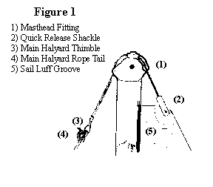
Support the mast at either end, between two boxes or chairs.
For the Tanzer 16 and Tanzer Overnighter, select main halyard and pass the end with the thimble through the mast head fitting, over both sheaves, so that the end with the quick release shackle is on the same side of the mast as the sail luff groove; this is the aft side of the mast (see Fig. 1). Secure the shackle to the large horizontal eye, located on the forward side of the mast. Secure the rope tail to the thimble at the other end of the halyard with a bowline knot. Take up the slack in the halyard and make up on one of the cleats on the mast. With the Tanzer 14, the main halyard wire is already installed in the mast. It is only necessary to secure the rope tail to the thimble with a bowline and make up on one of the cheats on the mast.
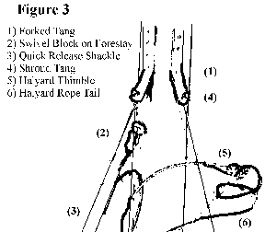
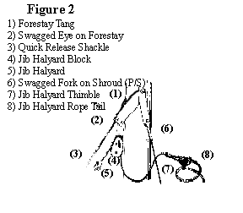
Select jib halyard. With the Tanzer 16 and Tanzer Overnighter, the strap on the halyard block should be attached, with the clevis pin supplied, to the lowest of the two holes in the forestay tang on the forward side of the mast, making sure that the end of the halyard with the quick release shackle is on the side of the block away from the mast (see Fig. 2). On the Tanzer 14, secure the U-strap of the halyard block to the lower of the two tangs on the front of the mast by means of the clevis and split pins provided (see Fig. 3). Do not forget to insert the split pin and bend over ends. The quick release shackle should then be secured to the horizontal eye, knot rope tail to thimble, and make up on other cleat on mast.
Select forestay. On the Tanzer 16 and Tanzer Overnighter, the swaged eye end should be attached to the upper of the two holes in the forestay tang, using the clevis pin and split pin provided (see Fig. 2). On the Tanzer 14, secure the swaged fork of the forestay to the upper of the two tangs, using the clevis and split pins provided (see Fig. 3). Do not forget to bend the ends of the split pins. Loosen turnbuckle to its fullest extent at both ends and remove clevis pin from fork of turnbuckle by taking out split pin or by un-screwing if the clevis pin has a threaded end. Keep these handy together with the toggle.
Select shrouds (two), and attach swaged fork terminal of each to shroud tangs on either side of the mast, using clevis pins and split pins supplied. Bend over ends of split pins. (See Fig. 2 and Fig. 3). Remove clevis pins from the lowest hole in the adjuster plates, and keep handy. Do not lose them, or the split pins.
The mast is now ready for stepping, and this should be done before the boat is put into the water. If your boat is resting on the ground, make sure that it is firmly chocked under both bilges; if on a trailer, make sure it is securely lashed down.
The Tanzer l6 mast has a cast aluminum slotted fitting in its base (or heel): this slot fits in the keelson in the bottom of the boat, just forward of the centreboard trunk and directly below the U shaped mast gate which is located in the deck at the forward end of the cockpit. The Tanzer Overnighter is fitted with a self-stepping mast hinge on top of the cuddy cabin. The Tanzer 14 mast has an open end which fits over the aluminum mast step casting installed on the deck just forward of the cockpit.
To step the mast, obtain the assistance of another person. With the Tanzer 16 and Tanzer 14, the mast should be raised to a vertical position outside the boat. One person then stands in the boat. Keeping mast vertical, lift and place mast heel in the position appropriate to the boat model (see para. 7 above). One person should then hold the mast in a vertical position on its step whilst the other secures the shroud adjusters to the chain plates, using clevis pins and split pins provided. The toggle on the end of the turnbuckle on the forestay should be inserted in the oval center hole of the bow filling, so that the holes in the end of the toggle are uppermost to receive the fork of the turnbuckle. In the case of the Tanzer Overnighter, the mast should be held horizontally, one person in the boat takes the base or heel of the mast whilst the other, outside and behind the boat, holds the head. The person in the boat should then attach the mast heel to the mast step on the cabin top by inserting the hinge bolt provided. Do not forget to put the nut on the bolt in the mast hinge. The adjuster plates should then be secured to the chain plates (see para. 9 below). The mast may then be raised to a vertical position; the person in the boat should push the mast upward whilst the person outside the boat pulls on the forestay from a position immediately in front of the boat.
The adjuster plates are attached to the shrouds through the second hole, and this should be the correct setting. However, the setting may vary slightly with individual boats, and it may be necessary to use a different hole. Try to keep the adjuster plate positions in symmetry with each other.
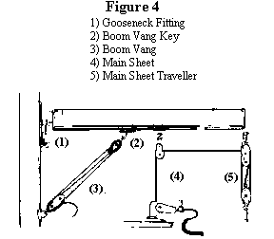
When mast is stepped, turn the barrel of the turnbuckle until it is about two thirds closed. The shrouds and forestay should now be taut: not so tight that they twang, nor floppy. If this is not so, loosen the turnbuckle and try another hole setting in the adjuster plates, moving the pin equally each side. One hole makes a very considerable difference. The correct setting will soon be found, and should remain constant for the life of the boat. The locknuts on the turnbuckles should then be tightened, and should be kept tight at all times. After un-stepping mast for storage or trailering, make sure that the turnbuckle is tightened or taped together so that it cannot come apart.
Place paddle-boom crutch in the opening in the after deck, making sure that in the case of the Tanzer 16 and Tanzer Overnighter, the rounded end fits also into the cup behind the bulkhead; or in the case of the Tanzer 14, on the pin on cockpit sole.
Select the boom and loosen thumbscrew in the gooseneck fitting. The slide may then be dropped into the stainless steel gooseneck track on the after side of the mast. Tighten thumbscrew and rest boom on boom crutch.
With the Tanzer 16 and Tanzer Overnighter, secure the two blocks on boom with the shackles provided. The single block should be attached to the boom bail in the middle of the boom, and the fiddle block to the plate at the after end of the boom (see Fig. 4). With the Tanzer 14 secure the single block to the boom bail in the middle of the boom (see Fig. 5). Tighten pins in shackles.
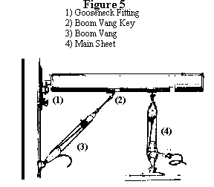
Select mainsheet (the longer of the two sheets in the kit). For the Tanzer 16 and Tanzer Overnighter, take one end and pass through block on centreboard cap - through block on center of boom, through the top or larger sheave of the fiddle block, down through the single block on the mainsheet traveler on the transom, up through the lower or smaller sheave of the fiddle block, and finally secure with bowline to the becket of the block on the traveler (see Fig. 4). Take up slack and secure in the swivel jamb cleat on centreboard cap. Tie a figure of eight knot in the loose end of mainsheet. For the Tanzer 14, pass one end of the main sheet through the lower sheave of the fiddle block installed in the boat on the centreboard cap; through the single block attached to the boom, through the small sheave in the fiddle block and then secure with a bowline knot to the becket of the block on the boom (see Fig. 5). Tie a figure of eight knot in the loose end of the main sheet.
The jib sheet should be passed through the cringle at the clew of the jib, centered, and then secured with a knot. Each end should then be rove through the sliding blocks installed on each side of the boat. With the Tanzer Overnighter, the sheets are also rove through the fairleads provided on each jamb cleat. On this boat, the jib sheets are cleated in the jamb cleats immediately behind the fairleads. On the Tanzer 16 and the Tanzer 14, the jib sheets are cleated in the jamb cleats on the opposite side of the boat. In the case of boats fitted with the optional pedestal with a snubbing winch installed on the center thwart of the Tanzer 16 or Tanzer 14, a turn of the jib sheet should first be taken around the snubbing winch and then cleated in the appropriate jamb cleat on the side deck.

HOISTING THE SAILS
Sails should not be hoisted unless the boat is free to swing head to wind.
Step 1: The bolt rope on the foot of the mainsail slides into the slot on the boom, by sliding the clew into the opening at the gooseneck and along the boom. The tack of the sail is then secured by passing the large split pin on fore end of the boom through the cringle in the tack of the sail. The line attached to the clew of the sail is then passed several times around the T shaped lug on the other end of the boom and through the cringle in the clew of the sail and made fast with a series of half hitches. The tightness in the foot of the sail should be appropriate to the wind strength: tight, be not too tight for strong winds, and less tight but not baggy for light winds. Should you boat be fitted with an adjustable clew outhaul, which is available as a factory installed option, the clew line should be removed from the sail and the quick release shackle secured to the clew cringle.
Step 2: The battens supplied should be inserted in the batten pockets in the mainsail. Do not fail to push the end of each batten well into each pocket, and downwards, so that they cannot slip out. Battens should be removed before folding and/or stowing the mainsail.
Step 3: The quick release shackle on the main halyard should be secured to the cringle in the head of the mainsail. Before hoisting the sail, check that the mainsheet is free to run and that the rope tail of the boom vang is not jammed. (The boom vang is installed in step 4.) The sail is hoisted by feeding the bolt rope on the luff of the sail into the slot in the mast and simultaneously pulling on the main halyard. Make sure that the thumbscrew on the gooseneck is loosened, so that the sail is hoisted to the very top of the sail slot. After sail is hoisted, make up rope tail on one of the cleats on the mast. Pull down gooseneck until the luff of the sail is taut, then tighten thumbscrew. Remove paddle/boom crutch and stow in boat.
Step 4: Select boom vang: Secure block with shackle supplied to vertical eye near the base of the mast. Loosen rope tail and place key in slotted plate in boom (see Figs. 4 & 5). Pull rope tail tight and jamb it in the cleat on the lower block.
Step 5: The tack of the jib should be secured to the after hole in the bow fitting with the shackle supplied in the jib halyard package. The sail is then hanked on to the forestay with the sail hanks fitted to the luff of the jib. The quick release shackle on the jib halyard should then be secured to the cringle in the head of the sail. Take care not to let the jib fill with wind or slip into the water before hoisting begins. Hoist sail by pulling on jib halyard and make up rope tail on the outer cleat. The luff of the jib should be as tight as possible on all points of sailing.

REEFING INSTRUCTIONS
To reef the mainsail of either the Tanzer 16 or the Tanzer Overnighter, slacken off the boom vang, and remove the boom vang key from the boom. Also unshackle the single block secured to the middle of the boom. Slacken off main halyard and pull boom away from the mast. Then rotate the boom and continue to slacken main halyard so that the sail rolls up on the boom. When sail is sufficiently reefed, allow boom to slip back over the square end of the gooseneck, and tighten the main halyard. The Tanzer 14 is also fitted with a roller-reefing gooseneck. However, in order to reef the mainsail, a reefing claw is required. The claw ring should be slipped over the aft end of the boom, and the small block on the center of the boom unshackled; the block is then secured to the claw ring. The sail can then be roller reefed in the same way as the Tanzer 16 or Overnighter. Any tendency for the claw ring to slide towards the mast can be corrected by fastening a line from the claw ring to the after end of the boom.

SNAPTITE CORKS
Three corks are supplied with the Tanzer 16: one is for the drain hole in the transom and the other two are for the drain holes in the base of each tank.
Three corks are supplied with the Tanzer Overnighter. One is for the drain hole in the transom and the other two are for the drain holes in the base of each side tank. N.B. Do NOT place corks in the holes at the after end of the cockpit seats in the Tanzer 16 or Overnighter. These holes are to drain water from the seats.
Three corks are supplied with the Tanzer 14. One is for the drain hole in the transom and the other two are for the drain holes in the base of each side tank. N.B. The diameter of the corks may be increased slightly by rotating the lever pin in a clockwise direction when the cork is in the unlocked position.

FLOTATION TANKS
The side tanks, or seats, and the bow tank of all models contain Styrofoam to provide sufficient flotation to support the boat and the normal crew weight in the event of swamping. These tanks should be drained regularly of any accumulation of water by removing the corks.

RUDDER AND TILLER
After mounting the rudder, make sure that the retaining clip is turned to a vertical position, so that it will prevent the rudder from being lost during a capsize. The later models, fitted with anodized aluminum rudder heads, instead of wooden, do not have a retaining clip installed. Instead, the top pintle has been drilled to accept a split pin, which must be removed in order to fit the rudder. After mounting the rudder, it is important that the split pin be replaced and then opened slightly.
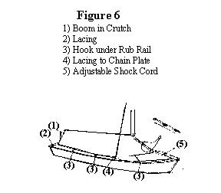
Also check that the split pin attached to the rudder head is inserted in the rudder cap and the hole provided in the tiller. The split pin should be opened slightly, to ensure a tight fit. The aluminum tillers supplied with later models are fitted with a spring retaining clip which must be depressed as the tiller is inserted or withdrawn from the aluminum rudder head.

COCKPIT COVER
The cockpit cover is designed to fit over the boom when the mast is stepped. This prevents rainwater, dirt and debris from collecting in the cockpit, both when the boat is a mooring or when being dry-sailed. It also serves as a boom tent for camping in the boat. Fig. 6. illustrates the correct way to fit the cover.

MAINTENANCE
Your boat requires a minimum of maintenance. It should be thoroughly washed down from time to time, and the fibreglass wax polished. A Simonize car wax polish containing a cleaner is quite suitable. A good polish once or twice during the season and before laying up will help keep the finish in excellent condition.
If your boat has teak woodwork, this should be well oiled at fairly frequent intervals; about once a month during the sailing season, with a suitable oil. If possible, use one of the proprietary teak oils that are available for marine use. If teak is not oiled regularly, it will, after exposure to sun and rain, weather to a dull grey colour. Once this has happened, sanding will be necessary to restore the surface to its original appearance. If your boat has varnished woodwork, this should be rubbed down and revarnished once a year at the beginning of the sailing season.

STORAGE
If you live in an area where below freezing temperatures are common during winter and you store your boat outside, it is important that it be completely dry when laid up and that it is either covered or turned over so that rain and snow cannot enter. Any substantial quantity of water trapped in restricted areas of the interior may cause damage on freezing.
If you turn your boat over for winter storage, make sure that it is properly supported. This is particularly important in areas with heavy snowfall since damage from the weight of accumulated snow can be extensive and is not covered by warranty.
If cross bearers are used, they should be placed so that the boat is supported on the after deck, side decks and foredeck. Because of the deck camber, wedges should be used to distribute the load as evenly as possible. Do not store the boat with the weight on the cockpit coamings. These are hollow and may crack. In any event, no substantial quantity of snow should be allowed to accumulate on the boat.

OUTBOARD MOTOR BRACKET
Two stainless steel bolts are installed in the port side of the transom of all models, to which an outboard motor bracket may be fitted. Specially designed brackets to fit these bolts are available from Tanzer Industries Ltd. or their authorized dealers.
It should be noted that these brackets are designed for motors of up to 3 H.P., which is quite adequate for the Tanzer Overnighter and Tanzer 16. A 2 H.P. motor is sufficient for the Tanzer 14. The outboard bracket is not designed for larger or heavier motors.
It is recommended that motors with an integral fuel tank be used and not those with separate tank and gas line. Outboard motors with a standard length shaft are suitable for all models.
When using the outboard bracket make sure that the safety line is attached and that this is passed through some part of the motor.

WHISKER POLE
A whisker pole can be fitted to all models and may be purchased as a factory-installed option when the boat is built or as a kit for subsequent installation by the owner. In the latter case, the whisker pole eye should be installed on the forward face of the mast in the position shown in the appropriate drawings. (Figs. 7, 8 and 8-A).

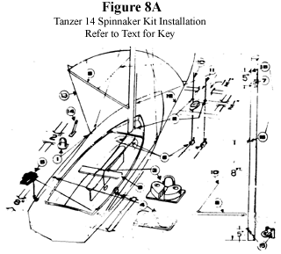
SPINNAKER GEAR
Spinnaker gear can be fitted to all models. This additional equipment may be purchased as a factory-installed option when the boat is built, or as a kit for subsequent installation by the owner.
If the spinnaker gear is already installed on your boat, the lines supplied comprising the spinnaker pole topping lift, the spinnaker halyard and the spinnaker sheet/guy should be rove as shown in the appropriate diagrams.
If, on the other hand, your boat is not equipped for a spinnaker, the kit may be purchased and installed as described below. When ordering a spinnaker kit for a Tanzer 16, please indicate whether or not your boat is fitted with a king's post.

Tanzer 16 and Tanzer 14 Spinnaker Kit Installation:
(Ref to Figs. 7 & 8-A).
Key:
Spinnaker guy or sheet hook: Install port and starboard with rubber "finger" inboard.
Through-deck fairlead: Install as shown. One for spinnaker halyard and one for spinnaker pole topping lift. Drill two 5/8" dia. holes in deck and secure with epoxy glue or similar.
Cam action jamb cleat with fairlead: Install two, side by side on center thwart; one for spinnaker halyard and one for spinnaker pole topping lift.
Cam action jamb cleat without fairlead: Install on side deck, port and starboard, as shown.
Cheek blocks: Install on after deck forward of cockpit cover deck straps if these are already fitted.
Block on deck strap: Install two; one is for the spinnaker halyard and the other for the spinnaker pole topping lift. If your boat is fitted with a king's post, install block on either side after bending straps to suit. These should be positioned on the king's post so as to line up with item 3. If your boat does not have a king's post, the blocks should be installed on the forward sloping face of the bow flotation tank. These should be placed so as to lead the spinnaker topping lift and halyard to the cam cleats on the center thwart.
Hound tangs (already installed on mast),
Spinnaker pole: clip to horizontal eye already installed on the mast.
Thwart.
Spinnaker pole topping lift: Tanzer l6 - 25' x 1/4" dia. Dacron line
Tanzer 14- 23' x 1/4" dia. Dacron line
Spinnaker halyard: Tanzer 16 - 46' x 1/4" dia. Dacron line
Tanzer 14 - 35' x 1/4" dia. Dacron line
Spinnaker sheet: Tanzer 16 - 35' x 1/4" dia. Dacron line
Tanzer 14 - 27' x 1/4" dia. Dacron line
Spinnaker guy: Tanzer 16 - 35' x 1/4" dia. Dacron line
Tanzer 14 - 27' x 1/4" dia, Dacron line
Chainplate.
Swivel block on strap: The upper block on the mast is for the spinnaker halyard and the lower for the spinnaker pole topping lift.
Whisker pole eye.

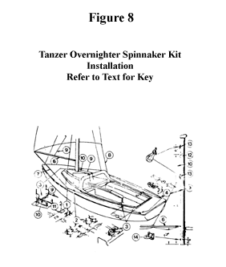
Tanzer Overnighter Spinnaker Kit Installation:
(Refer to Fig. 8).
Key:
Spinnaker guy or sheet hook: Install port and starboard with rubber "finger" inboard.
Cam action jamb cleat with fairlead: Install two, side by side on angled edge of cuddy top; one for spinnaker halyard and one for spinnaker topping lift.
Cam action jamb cleat without fairlead: Install on side deck, port and starboard as shown.
Cheek blocks: Install on after deck forward of cockpit cover deck straps if these are already fitted.
Block on offset strap: Install two; bend straps to suit configuration of mast step. One is for the spinnaker halyard and the other for the spinnaker pole topping lift.
Spinnaker pole: Clip to horizontal eye already installed on mast.
Spinnaker guy: 35' x 1/4" dia. Dacron line
Spinnaker sheet: 35' x 1/4" dia. Dacron line
Spinnaker pole topping lift: 17' x 1/4" dia. Dacron line
Spinnaker halyard: 40' x 1/4" dia. Dacron line
Chainplate.
Hound tangs (already installed on mast).
Swivel block on strap: The upper block on the mast is for the spinnaker halyard and the lower for the spinnaker pole topping lift.
Whisker pole eye.

HIKING STRAPS
Hiking straps can be fitted to all models. This additional equipment may be purchased as a factory-installed option when the boat is built, or as a kit for subsequent installation by the owner. The method of installation differs slightly with each model as follows:
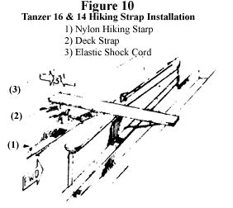
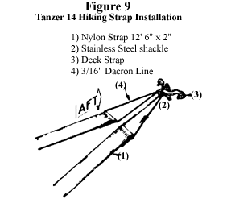
Tanzer 16 and Tanzer 14:
Install deck strap on underside of thwart and secure elastic shock cord loops with figure of eight knots as shown in Fig. 10.
The nylon strap should be passed through the shock cord loops and around the forward end of the centreboard trunk as shown in Fig. 10.
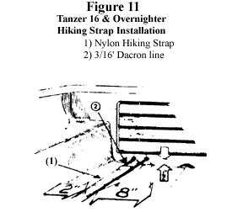
On the Tanzer 16, drill four 1/4" dia. holes in aft bulkhead and pass the 3/16" dia. Dacron line through these holes and the loops in the end of the strap, tighten and secure with reef knot as shown in Fig. 11.
On the Tanzer 14, remove inner pair of bolts from lower gudgeon and replace with longer bolts supplied. Flatten deck strap slightly and bend to fit inner bolts. Replace nuts and tighten. Install shackle and secure hiking strap with 3/16" dia. Dacron line as shown in Fig. 9.

Tanzer Overnighter:
1 Double ends of straps and fasten to top of bow deck with self-tapping screws and finishing washers as shown in Fig. 12

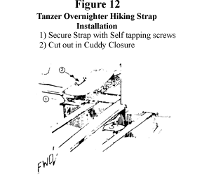
Drill four 1/4" dia. holes in aft bulkhead and pass the 3/16" dia. Dacron line through these holes and the loops in the ends of the straps, tighten and secure with a reef knot as shown in Fig. 11.
If cuddy closure is already fitted, this must be cut and additional snap fasteners installed as shown in Fig. 12.
The nylon hiking straps and the Dacron line will stretch slightly during use. Consequently, it may become necessary to tighten the straps by adjusting the tension of the Dacron line. This line should be inspected periodically for wear and be replaced as necessary.

OPTIONAL MAINSHEET TRAVELLER
A full width adjustable mainsheet traveller is available for the Tanzer 16 and the Tanzer Overnighter, either as a factory-installed option or as a kit for owner installation.
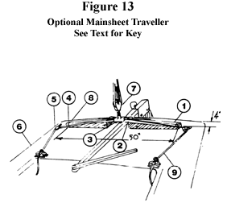
This should be installed as shown in Fig. 13. The standard traveller should be removed by unscrewing the nuts on the underside of the after deck and the optional traveller installed as follows:
Key:
2,3: Teak traveller supports (P/S): Install about 4" forward of edge of after deck. Drill supports and deck simultaneously to ensure correct alignment of holes. Caulk holes and thru-bolt with bolts supplied.
1: Traveller track: Install on supports with screws provided.
Traveller carriage: Fit to track before installing stops.
8: Track stops (P/S): Fasten to teak supports with screws provided.
5: Turning block on strap (P/S): Thru-bolt to deck as shown after caulking holes.
6: Cam action jamb cleat with fairlead (P/S): Install on cockpit coaming as shown with self-tapping screws. Caulk holes.
7: Single swivel block with becket: Shackle to traveller and reeve mainsheet as previously (see Fig. 4).
4: Deck strap (P/S): Install at outboard ends of teak supports on aft side.
9: Traveller control lines (P/S): these are 1/4" dia. braided Dacron and should be rove as shown. Tie a figure of eight knot in both ends of each.

GELCOAT REPAIRS
Gelcoat is the pigmented layer of polyester resin that forms the outer skin of all molded fibreglass components of your boat. To repair minor scratches, chips and abrasions in this Gelcoat, the procedure is:
Ideally, all such repairs should be carried out in dry conditions with the air temperature between 65F and 70F.
Thoroughly sand the damaged area with No. 80 dry sandpaper.
Clean with acetone. This is highly flammable and usually obtainable from a drug store. It should be used and stored with appropriate caution.
Place an appropriate quantity of Gelcoat on a clean piece of wood or cardboard. Catalyst should then be added. At 65F - 70F, a teaspoonful of Gelcoat requires 3-4 drops of catalyst to effect a reasonably rapid cure. Mix together until it is apparent that the Gelcoat is thickening.
The Gelcoat should then be laid into the scratch or chip and smoothed. The surface of the repair should be slightly higher than the surrounding Gelcoat. This should be left to cure until it is quite hard. If a clean piece of polyethylene is laid over wet Gelcoat to exclude air, this will hasten the curing. In the case of deep scratches, it may be necessary to build up successive layers of Gelcoat. If working on a vertical surface, allow the Gelcoat to thicken sufficiently to prevent running before applying.
When completely cured, the repaired, raised surface should be sanded initially with No. 100 dry sandpaper using a sanding block until it is almost level with the surrounding Gelcoat. It should then be sanded with No. 400 waterproof sandpaper, using plenty of water until it is level. Great care should be taken not to rub away the Gelcoat around the repair.
When all is level, sand again with No. 600 waterproof sandpaper and plenty of water.
The repaired area should then be buffed with a fine rubbing compound. When buffing, apply considerable pressure. Polishing with a proprietary fibreglass polish such as "Trewax" will produce a high gloss.

STANDING AND RUNNING RIGGING
All wire rigging, both standing and running, should be carefully examined when laying up for the winter or when fitting out in the spring. Look for broken strands in the wire, badly worn terminal fittings, clevis pins and shackles. Any wire with a broken strand or worn fittings should be replaced, as should worn pins and shackles. Check all turnbuckles and toggles. If bent or worn at the holes, replace them.
Examine all rope running rigging regularly, particularly when fitting out, and replace if worn. Split pins and rings should be renewed each year when fitting out.

FITTINGS
Periodically check the fastenings of all the fittings on the mast and boom as well as those on deck. In particular, make sure that all fastenings are secure on the mast whenever this is unstepped. At the same time examine the masthead fitting for worn sheaves, pins and shackles and replace if necessary. The rudder gudgeons and pintles should be checked for wear at least once a year.

CARE OF SAILS
The sails supplied with your boat by the factory are made of synthetic fibers; all except the spinnaker are of polyester fibre called Dacron in North America, and Terylene in England. The spinnaker is made of nylon. Contrary to cotton sails, they do not require careful stretching and breaking in, when new. They do, however, require proper care and maintenance.
Because of the nature of the cloth., the stitching on synthetic sails protrudes slightly above the surface of the sailcloth. This exposed stitching is vulnerable to chafe, particularly in certain areas. The head and clew, batten pockets, luff and foot, and that part of the mainsail that lies against the shrouds when running are all subject to chafe. Therefore all stitching in these areas should be checked periodically and renewed as necessary.
Excessive flogging, or flapping from side to side, will spoil the shape of a sail, and in extreme conditions, will tear it.
Wet sails should be dried as soon as is practical. Synthetic fibers will not rot due to moisture, but this will cause mildew if sails are stored for long periods when damp. Do not furl a wet sail; stow it as loosely as possible so air can circulate. When storing sails, make certain that they are completely dry.
Sails can become soaked with salt spray. When this dries a deposit of salt is left in the cloth. This not only stiffens the sail and prevents its setting correctly, the salt, being hygroscopic, will absorb moisture whenever there is any in the atmosphere, and the sail will become damp. Consequently it is essential to wash salt encrusted sails periodically, particularly before storing them. They should be washed with copious amounts of fresh water and scrubbed gently with a soft brush. Dirty sails may require lukewarm water and a mild detergent. Dry in the sun. Grease and oil stains should be removed with carbon tetrachloride or trichloroethylene.
Wrinkles and crease marks render a sail less efficient. Consequently when furling a mainsail on the boom, it should be flaked down carefully. When bagging a sail, it should be folded parallel to the foot, using existing folds if possible, and then rolled loosely around the luff.
Continuous exposure to sunlight over a long period will cause polyester and nylon fibers to deteriorate, and ultimately to disintegrate. Since sails will be exposed to sunlight a good deal during normal use, it is prudent to reduce such exposure when not sailing.

ADJUSTABLE CLEW OUTHAUL
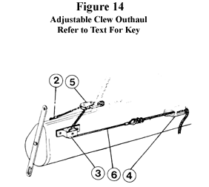
This permits adjustment of the tension in the foot of the mainsail whilst sailing. If already fitted to your boat as a factory installed option, the Dacron clew line which is supplied as standard on the mainsail should be removed and the clew of the mainsail secured with the small shackle and block provided, as shown in Fig. 14. A kit to install an adjustable clew outhaul may be purchased from the factory. Installation details are as follows:

Key:
The aluminum cleat and stainless steel deck strap for the standard clew line should be removed, and the holes plugged with rivets.
Nicopress eye and thimble in wire: Secure to boom with rivet.
Turning block: Secure to boom with rivet.
Clam cleat: Secure to boom with self-tapping screws or rivets.
Single block and shackle: Secure to clew cringle on mainsail.
Dacron line (3/16" dia.): Should be rove through clam cleat. Tie a figure of eight knot in end.

